Just few simple steps to create the kiteboard of your style
- To choose the board size that fits your condition.
Specifications of our kiteboards are as bellow:
Unit: CM/KG
Mode | 128X38 | 130X36 | 130X39 | 131X40 | 132X40 | 133X40 | 135X39
Minimum order quantity | 1 | 1 | 1 | 1 | 1 | 1 | 1
Flexibility | High | High | High | High | Low | Low | High
Bottom Concave | NO | NO | NO | NO | 3 mm | 4 mm | NO
OVERALL LENGTH (L) | 128 | 130 | 130 | 131 | 132 | 133 | 135
CENTER WIDTH (W) | 38 | 36 | 39 | 40 | 40 | 40 | 39
FRONT/RAIL WIDTH (T) | 26 | 24 | 27 | 27 | 27 | 27 | 26
HANDLE WIDTH (C) | 20 | 20 | 20 | 20 | 20 | 20 | 20
TIP/TAIL HEIGHT (H) | 4 | 3.2 | 3 | 3.8 | 4.3 | 4.5 | 3.6
Board Net Weight | 2.4 KG | 1.9 KG | 2.1 KG | 2.5 KG | 2.7 KG | 2.8 KG | 2.4 KG
Total Weight (Board complete with pads,straps and fins, etc.) | 3.4 KG | 2.9 KG | 3.1 KG | 3.5 KG | 3.7 KG | 3.8 KG | 3.4 KG

Mode | 135X41 | 136X42 | 138X42 | 140X42 | 145X43 | 146X45
Minimum order quantity | 1 | 1 | 1 | 1 | 1 | 1
Flexibility | Low | High | Low | High | Low | High
Bottom Concave | 3 mm | NO | 3 mm | NO | 3 mm | No
OVERALL LENGTH (L) | 135 | 136 | 138 | 140 | 145 | 146
CENTER WIDTH (W) | 41 | 42 | 42 | 42 | 43 | 45
FRONT/RAIL WIDTH (T) | 28 | 29 | 30 | 28 | 30 | 28
HANDLE WIDTH (C) | 20 | 20 | 20 | 20 | 20 | 20
TIP/TAIL HEIGHT (H) | 4.3 | 3.8 | 4.5 | 4.4 | 5 | 5.2
Board Net Weight | 2.7 KG | 2.8 KG | 2.9 KG | 2.8 KG | 3.1 KG | 3.3 KG
Total Weight (Board complete with pads,straps and fins, etc.) | 3.7 KG | 3.8 KG | 3.9 KG | 3.8 KG | 4.1 KG | 4.3 KG

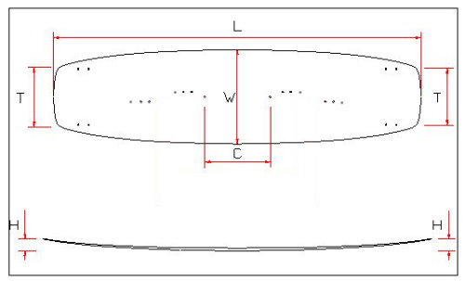

- Please fill out the order form as below, then send it to hank@anti--g.com.

Order Form
The kiteboard’s size you want to order | ex. 135X42
There are 3 ways to have the graphic on your kiteboard as bellow,
- The graphic is designed by yourself
We provide templates of Adobe illustrator, Coreldraw and photoshop to help you to create your graphic.
We accept these software and version as bellow:
Software | Adobe illustrator | photoshop | Coreldraw
Version（If you use too new version to design your graphic, our machine maybe can’t print it.） | CS 5 | CS 5 | X 6
Dpi Resolution demand | 150dpi or above
If you will use Adobe Illustrator to design your graphic, please download the following template of kiteboard to start your own design. We make the templates with Adobe Illustrator 8.
128X38(128k), 130X36(181k), 130X39(182k), 131X40(99k), 133X40(90K), 135X39(178k), 136X42(93k), 140X42(180k), 146X45(180K)
If you will use Coreldraw to design your graphic, please download the following template of kiteboard to start your own design. We make the templates with Coreldraw 11.

128X38(44k), 130X36(33k), 130X39(35k), 131X40(27k), 133X40(28K), 135X39(32k), 136X42(29k), 140X42(32k), 146X45(34K)
If you will use Adobe Photoshop to design your graphic, please download the following template of kiteboard to start your own design. We make the templates with Adobe Photoshop 7.

128X38(14M), 130X36 (13M), 130X39(13M), 131X40(14M), 133X40(14M), 135X39(13M), 136X42(14M), 140X42(14M), 146X45(28M)
Regarding how to use our template to create your graphic, please follow the steps as bellow,
- You can see there are 3 graphic layers in our templates of graphic.
- The first layer is the gray color. It can help you to understand the position of foot pads, handle and fins.
- The second layer is red line and dots. It will let you know Graphic inside the red line will be appeared on your kiteboard. You also can understand the screws position from this layer.
- The third layer is black line. It will let you know that your graphic needs to be extended beyond the red line and reaches the black line to fill up the entire template.
- However, graphic outside the red line of the template will probably be lost in the process of manufacturing your kiteboard.
- Please match all the pictures you design into one picture to become the fourth layer of graphic.
- We will take off the first, second and third layer before printing graphic.
- We just keep the graphic’s layer that you design and use it to make your kiteboard.
P.s.
We also accept JPG and the TIF format files, but please make sure the graphic file exceeds 1 mega pixel. As the graphic file is intended for printing, a resolution of over 150dpi is recommended.
Please post the thumbnail image you want to print on the front of the kiteboard at here (Pads and Handle side).  Please upload your full image to https://drive.google.com/ and tell us the download address of it, then we can download your image. | 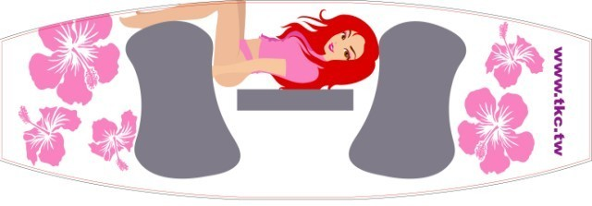
Please post the thumbnail image you want to print on the back of the kiteboard (Fins side). | 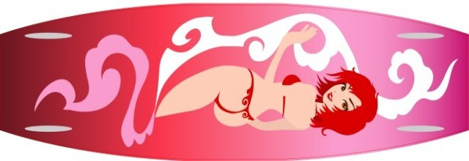
- You can choose our graphics to create your kiteboard. Please choose the graphic from http://www.tretow.idv.tw/antig/view_designer.php
Please tell us which image you want to print on the front of your kiteboard (Pads and Handle side)? | Fill in the Image No. you select from Anti-G graphic gallery. (ex. 10345)
What is the text you want to add on the front of your kiteboard? | Only text can be added. You can add your name, telephone no., company name, etc. (If there is no text to be added, please key in “do not need text “here.)
Which image you want to print on the back of your kiteboard (Fins side). | Fill in the Image No. you select from Anti-G graphic gallery. (ex. 15678)
What is the text you want to add on the back of your kiteboard? | Only text can be added. You can add your name, telephone no., company name, etc. (If there is no text to be added, please key in “do not need text “here.)
3. Paying us some fee for designing your graphic.
If you cannot use the software to make graphic for your kiteboard, we can make the graphic for you with US$ 20 ~ 100 design fee.
The charge of design fee is detailed as below:
- We will inform you about the amount of design fee before start to design your graphic.
- You can revise twice for free after we finish your graphic.
- If you revise your graphic over twice, extra US$ 10 will be charged for each revision from the third time.
- If the graphic we produce for you cannot meet your expectations, we will refund US$50 design fee to you.
You can draw your graphic on a piece of paper or using any painting tools in computer such as Windows MS Paint, Microsoft Word, Ulead Photoimpact, etc. to design your graphic.
After you finish your design, please send the file of your graphic to hank@anti--g.com . We will make your graphic with Adobe Illustrator. Then, we will send you the graphic when we finish it.
We will start to produce your kiteboard after getting your confirmation.
We provide 4 sizes in 6 colors of fins that you can choose to match your board. There are 1.5, 1.75, 2 and 2.25 inch in white, black, orange, green, blue and clear color fins. The big fins are good for using by beginners, upwind and the wave condition. The small fins are good for the flat water condition or advancers who want to increase the sensitivity of the board. Adding US$ 20, you can get one extra set of fins. | ex: I choose 2.25 inch in white color fins.  ex: I hope to order one extra 1.5 inch in white color fin set （adding US$ 20）
Personal information and Payment Methods
Name
Address
Tel.
E-MAIL
Payment Method (Paypal, Credit card, Bank telegraphic transfer, West Union etc.)  If you pay us the payment via paypal, you can get the 180 days buyer protection of paypal. | Ex：Paypal

- Once we have all the necessary information for producing your custom kiteboard, we will send you a layout of your kiteboard to let you confirm.
- We will notify you the total amount, including shipping fees.
- We will start to produce your kiteboard after getting your payment. Your kitebaord will be finished in about 10-32 days.
- We will tell you the tracking number of your kiteboard after we ship it.
- We offer 360 days guarantee for the quality of our products.

